SAVEETHA SCHOOL OF ENGINEERING

SAVEETHA INSTITUTE OF MEDICAL AND TECHNICAL SCIENCES

ITA 0443 - STATISTICS WITH R PROGRAMMING FOR REAL TIME PROBLEM

DAY 4– LAB MANUAL

Reg No: 192110320

Name: U Mohan Srinivas

LINEAR REGRESSION ANALYSIS IN R

Exercise

1. Using linear regression analysis establish a relationship between height and weight of a

person using the input vector given below.

# Values of height

151, 174, 138, 186, 128, 136, 179, 163, 152, 131

# Values of weight.

63, 81, 56, 91, 47, 57, 76, 72, 62, 48

Predict the weight of a person with height 170. Visualize the regression graphically.

STEPS FOR PERFORMING LINEAR REGRASSION:

Step-1: Install and load the necessary packages

Step-2: Define the input vectors for height and weight

Step-3: Create a data frame with the height and weight

Step-4: Perform the linear regression analysis

Step-5: predict the weight of a person with height 170

Step-6: visualize the regression graphically

SOURCE CODE:

install.packages("ggplot2")

library(ggplot2)

height <- c(151, 174, 138, 186, 128, 136, 179, 163, 152, 131)

weight <- c(63, 81, 56, 91, 47, 57, 76, 72, 62, 48)

data <- data.frame(height, weight)

model <- lm(weight ~ height, data = data)

new_height <- data.frame(height = 170)

predicted_weight <- predict(model, newdata = new_height)

predicted_weight

ggplot(data, aes(x = height, y = weight)) +

geom_point() +

geom_smooth(method = "lm", se = FALSE, color = "blue") +

labs(x = "Height", y = "Weight", title = "Linear Regression") +

theme_minimal()

OUTPUT:

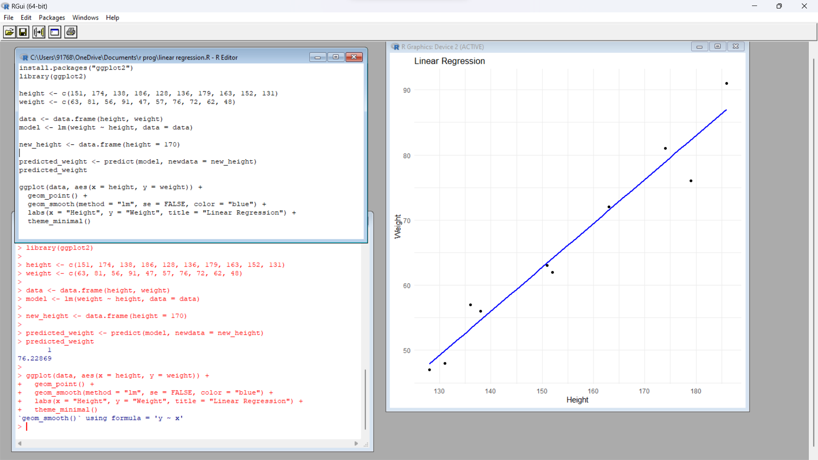

2. Download the Dataset &quot;water&quot; From Rdataset Link.Find out whether there is a linearrelation between attributes&quot;mortality&quot; and&quot;hardness&quot; by plot function.Fit the Data into theLinear Regression model.Predict the mortality for the hardness=88

SOURCE CODE:

OUTPUT:

MULTIPLE REGRESSION ANALYSIS IN R

3.Generate a multiple regression model using the built in dataset mtcars.It gives a comparison

between different car models in terms of mileage per gallon (mpg), cylinder

displacement(&quot;disp&quot;), horse power(&quot;hp&quot;), weight of the car(&quot;wt&quot;) and some more parameters.

Establish the relationship between &quot;mpg&quot; as a response variable with &quot;disp&quot;,&quot;hp&quot; and &quot;wt&quot; as

predictor variables. Predict the mileage of the car with dsp=221,hp=102 and wt=2.91.

SOURCE CODE: data(mtcars)

model <- lm(mpg ~ disp + hp + wt, data = mtcars)

summary(model)

new_data <- data.frame(disp = 221, hp = 102, wt = 2.91)

prediction <- predict(model, newdata = new_data)

prediction

OUTPUT:

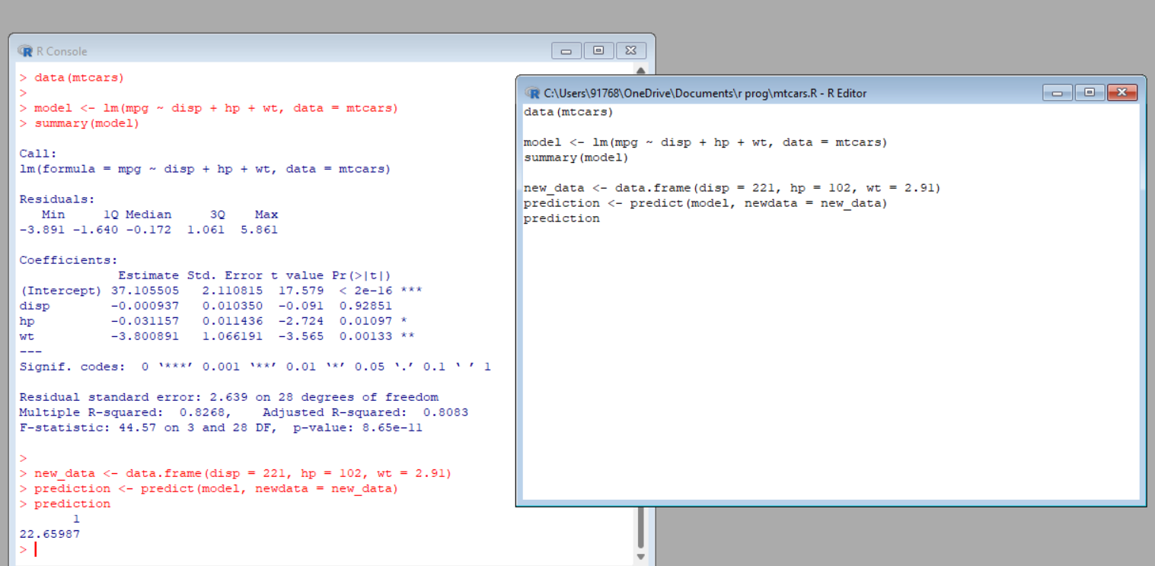

4. Consider the data set &quot;delivery&quot; available in the R environment. It gives a deliverytime

(“delTime”)of production materials(number of productions “n.prod”) with the given

distance(“distance”) to reach the destination place.

a)Create the model to establish the relationship between &quot;delTime&quot; as a response

variable with &quot;n.prod&quot; and &quot;distance&quot; as predictor variables.

b)Predict the delTime for the given number of production(“n.prod”)=9 and

distance(“distance”)=450

SOURCE CODE:

data(delivery)

model <- lm(delTime ~ n.prod + distance, data = delivery)

summary(model)

newdata <- data.frame(n.prod = 9, distance = 450)

prediction <- predict(model, newdata)

Prediction

OUTPUT:

